Additional files 1
Figure S1. Kinship hist of the 112 accessions.
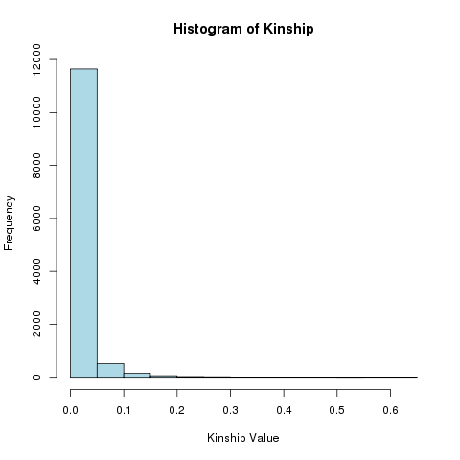
Figure S2. PCA analysis in 112 accession of ramie.
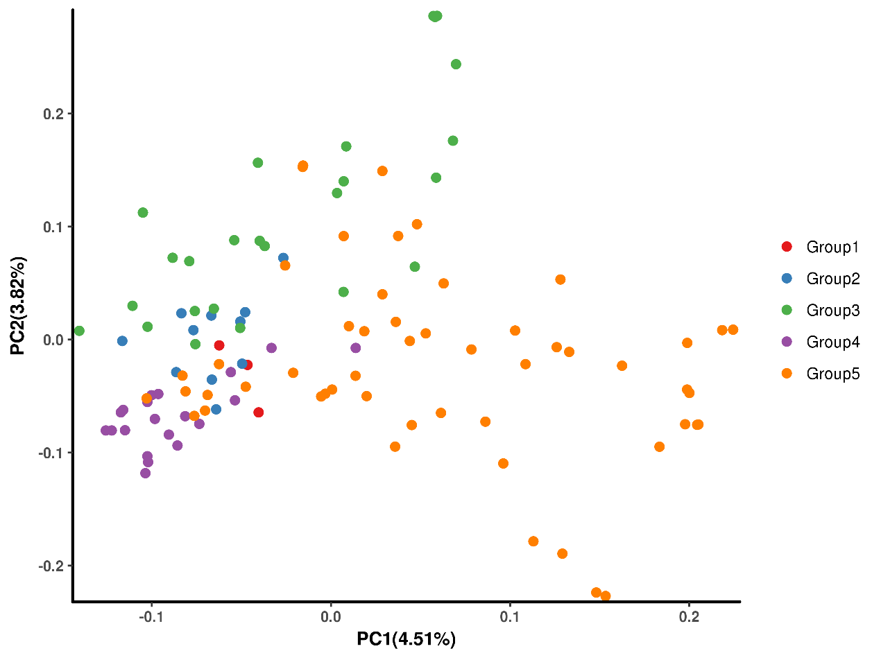
Figure S3 Quantile-quantile (Q–Q) plot of GLM-Q model.
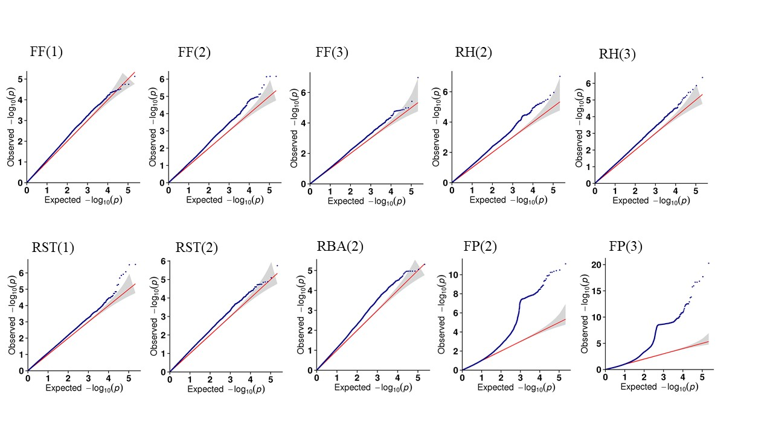
Figure S4. Quantile-quantile (Q–Q) plot of MLM-Q+K model.
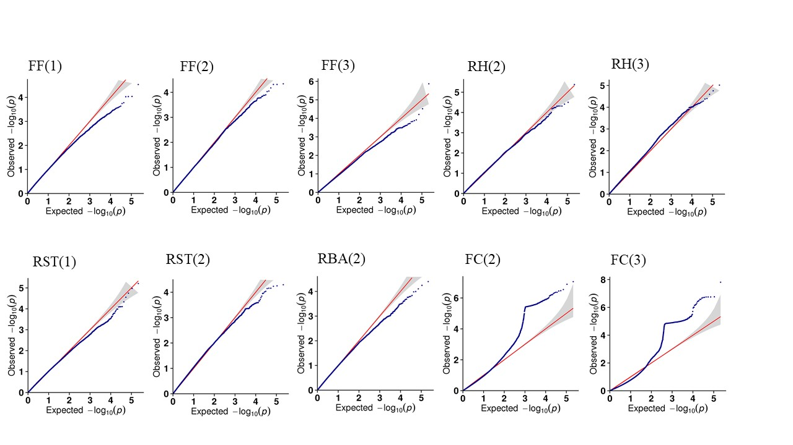
Figure S5. Quantile-quantile (Q–Q) plot of EMMAX model.
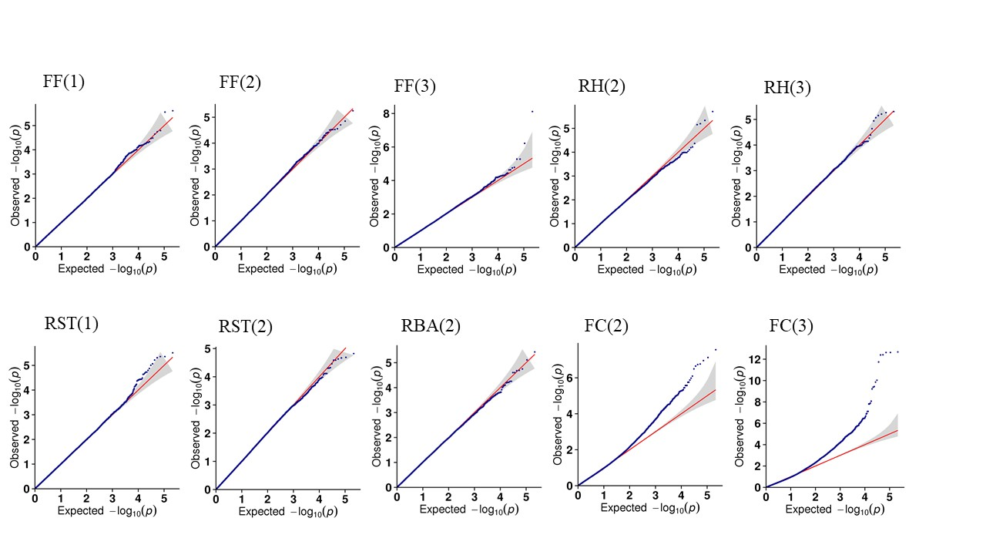
Figure S6. Manhattan plots and Q-Q plots of SNP markers for fiber fineness of third season.
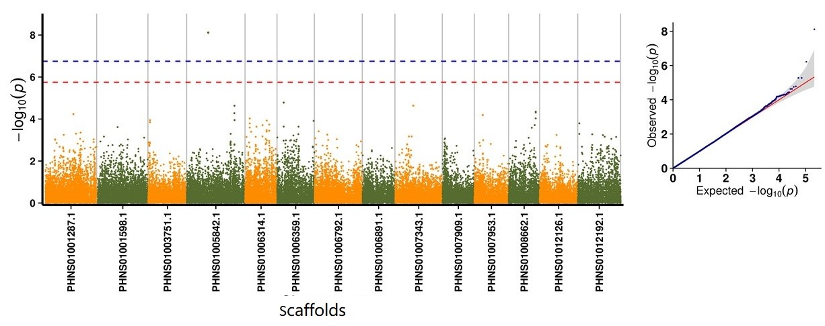
Figure S7. Manhattan plots and Q-Q plots of SNP markers for fiber percentage of second season.
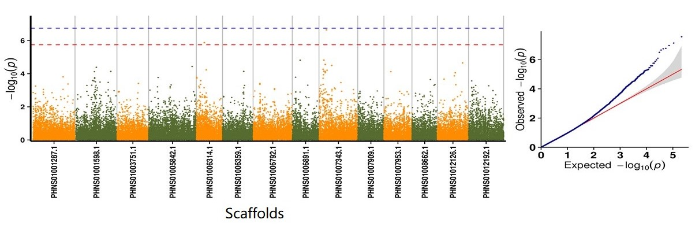
Figure S8. Manhattan plots and Q-Q plots of SNP markers for fiber percentage of third season.
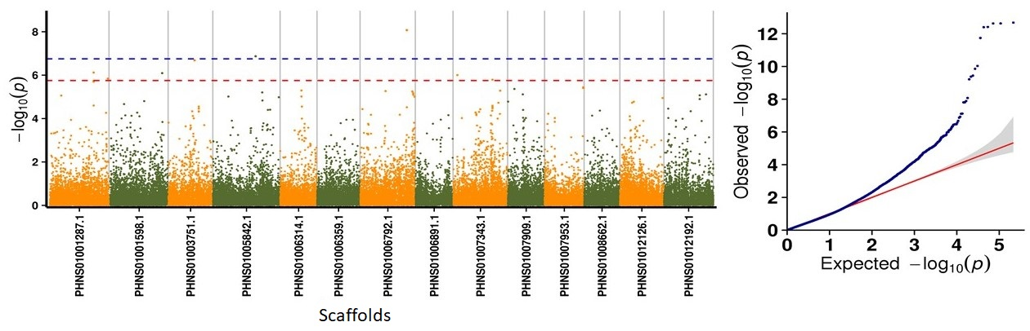
Figure S9. Relative expression of candidate genes of stem diameter in third season.
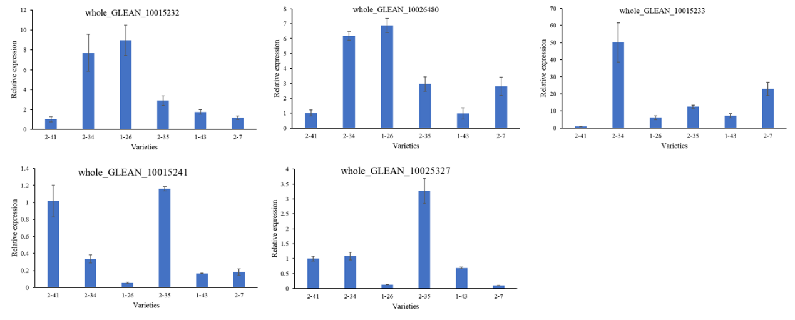
Figure S10. Relative expression of candidate genes of SKT in third season.
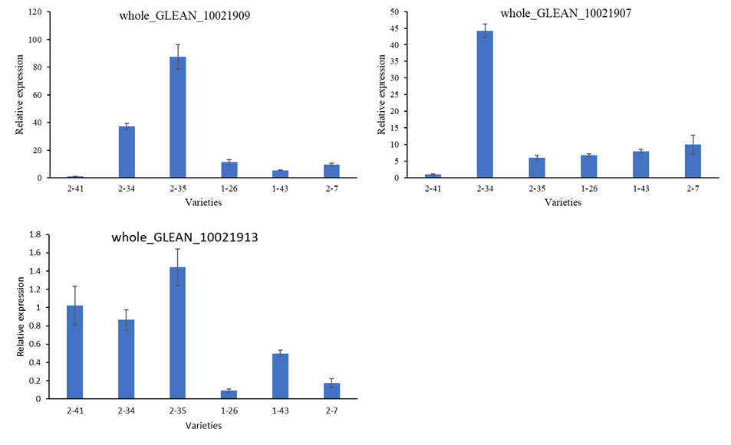
Figure S11. Relative expression of candidate genes of PC of second season.
